**ASSIGNMENT NO.6.**

**Aim :-**

Read the marks obtained by students of second year in an online examination of particular subject. Find out maximum and minimum marks obtained in that subject using heap data structure.

**Program Code:-**

#include<iostream>

using namespace std;

class hp

{

int heap[20],heap1[20],x,n1,i;

public:

hp()

{ heap[0]=0; heap1[0]=0;

}

void getdata();

void insert1(int heap[],int);

void upadjust1(int heap[],int);

void insert2(int heap1[],int);

void upadjust2(int heap1[],int);

void minmax();

};

void hp::getdata()

{

cout<<"\n enter the no. of students";

cin>>n1;

cout<<"\n enter the marks";

for(i=0;i<n1;i++)

{ cin>>x;

insert1(heap,x);

insert2(heap1,x);

}

}

void hp::insert1(int heap[20],int x)

{

int n;

n=heap[0];

heap[n+1]=x;

heap[0]=n+1;

upadjust1(heap,n+1);

}

void hp::upadjust1(int heap[20],int i)

{

int temp;

while(i>1&&heap[i]>heap[i/2])

{

temp=heap[i];

heap[i]=heap[i/2];

heap[i/2]=temp;

i=i/2;

}

}

void hp::insert2(int heap1[20],int x)

{

int n;

n=heap1[0];

heap1[n+1]=x;

heap1[0]=n+1;

upadjust2(heap1,n+1);

}

void hp::upadjust2(int heap1[20],int i)

{

int temp1;

while(i>1&&heap1[i]<heap1[i/2])

{

temp1=heap1[i];

heap1[i]=heap1[i/2];

heap1[i/2]=temp1;

i=i/2;

}

}

void hp::minmax()

{

cout<<"\n max marks"<<heap[1];

cout<<"\n##";

for(i=0;i<=n1;i++)

{ cout<<"\n"<<heap[i]; }

cout<<"\n min marks"<<heap1[1];

cout<<"\n##";

for(i=0;i<=n1;i++)

{ cout<<"\n"<<heap1[i]; }

}

int main()

{

hp h;

h.getdata();

h.minmax();

return 0;

}

**Output Screenshots:-**

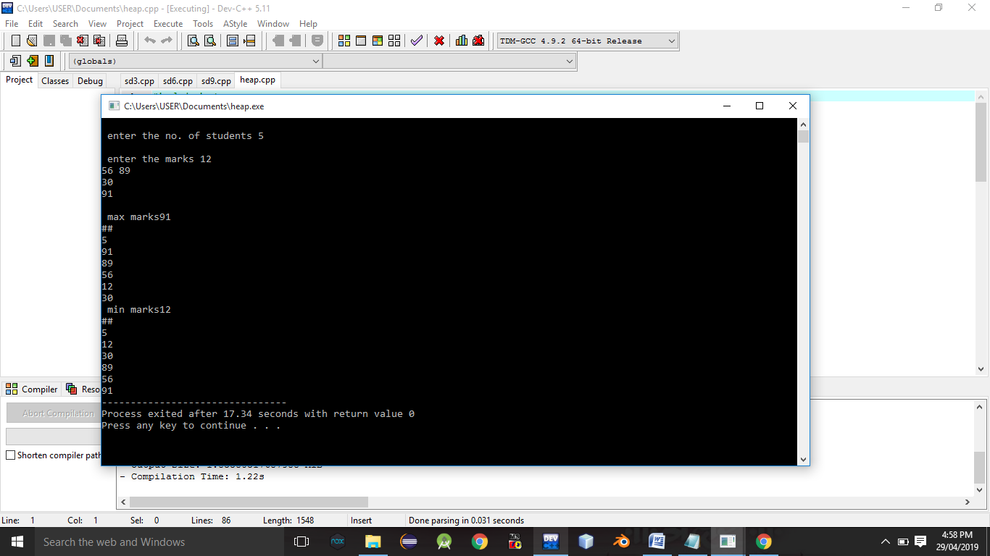

**Conclusion:-** Thus,we have studied heap data structure,